Year 1 Newsletter
Spring Term 2
Welcome back I hope you had a great week off!
Our plans for this term…
This term we have got lots of exciting things ahead, we are going to be looking at seasonal changes in science, creating animated story books in computing, understanding why some places in world are hot and others are cold for geography and creating stable structures for DT, as well as celebrating World Book Day, Mother’s Day, Red Nose Day and Easter – a very busy term ahead of us!


Literacy
In Literacy we will be focusing on writing poems using the book, Poems to Perform by Julia Donaldson. We will also be focusing on rereading and evaluating our writing and using expanded noun phrases.

Phonics
In Phonics, we are starting to revise the sounds we learnt in the beginning of year 1, implementing them in our daily writing to create more detailed sentences. To start preparing the children for the phonics screening check we will be using real and nonsense word reading activities.

Maths
In maths we will be finishing off our learning on addition and subtracting to 20 by looking at doubles and near doubles, subtraction using number bonds and solving number problems. Then we will be moving onto place value and looking at number beyond 20.

Reading
We will continue to complete reading checks on Monday and give out new Monster Phonics books. We are asking for book folders to be in school every day. As a school we ask that reading at home is done at least 3 times a week and a family member signs their reading record book.

Continuous Provision & Rainbow Challenges
In year 1, we continue to offer a rich and engaging continuous provision environment that supports all areas of learning. A highlight of our week is the Rainbow Challenge - children are encouraged to complete five activities throughout the week, each linked to a different area of learning and represented by a colour. Once they've collected all five, they receive a prize to celebrate their effort and resilience. It’s a fun and motivating way to encourage independence, exploration, and a love of learning!

Timetable
Below I have attached a rough outline of what we will be doing each day – it looks very confusing with all the colours, I know!
Blue is for writing, reading or phonics. Green is for maths. Yellow is for topic-based lessons and then lastly, red is for provision.

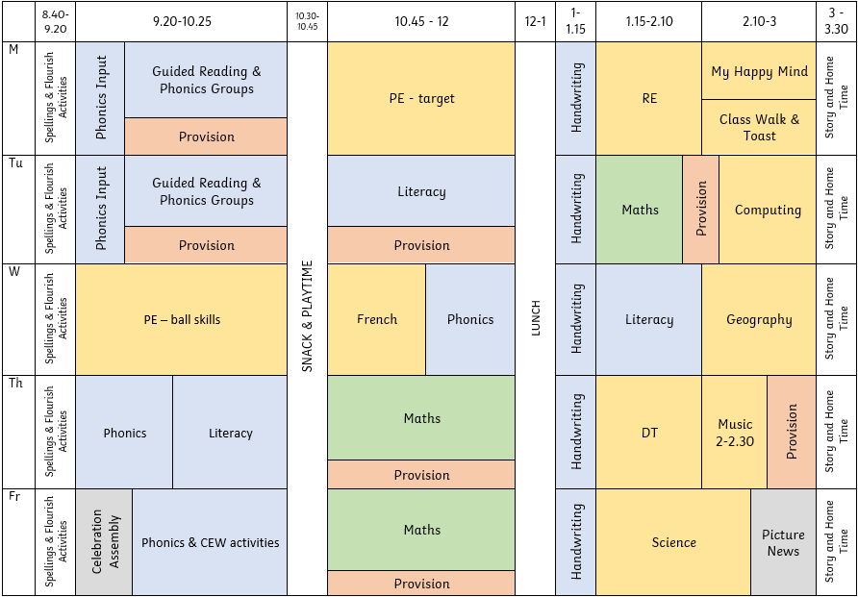

Things I need to remember…
- PE days – Monday & Wednesday
- To bring my book folder in everyday

If you have any questions or concerns, please don’t hesitate to message me on Class Dojo!

