Year 1 Newsletter
Summer Term 1
Welcome back I hope you had a great Easter!
Our plans for this term…
This term we have got lots of exciting things ahead, we are going to be looking at primary colours in art, ‘why do we like to be beside the seaside’ in geography, plants in science, why should we care for others in RE, maze explorers in computing, who helps to keep us safe in PSHE and for PE we are off to Forest School and Beach School!

Literacy
In Literacy we will be focusing on writing our own adventures stories using the classic story of ‘We’re Going on a Bear Hunt’ by Michael Rosen.
In GPS lessons we will be focusing on questions and single/plural nouns.
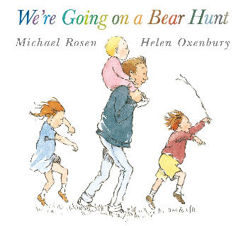

Phonics
In Phonics, we are revising all the sounds we’ve previous learnt, using them in our daily writing. This term is all about preparing them ready for the Phonics Screening Check, there is more information on ClassDojo and our class page on the school website.

Maths
In maths we will be focusing on measurement, in particular mass and volume, we then will move onto multiplication & division and learning how to count in 2’s, 5’s and 10’s. Then towards the end of the term we will also start looking at fractions – a very busy term for maths!

Reading
We will continue to complete reading checks on Monday and give out new Monster Phonics books. We are asking for book folders to be in school every day. As a school we ask that reading at home is done at least 3 times a week and a family member signs their reading record book.

Continuous Provision & Rainbow Challenges
In year 1, we continue to offer a rich and engaging continuous provision environment that supports all areas of learning. A highlight of our week is the Rainbow Challenge - children are encouraged to complete five activities throughout the week, each linked to a different area of learning and represented by a colour. Once they've collected all five, they receive a prize to celebrate their effort and resilience. It’s a fun and motivating way to encourage independence, exploration, and a love of learning!

Timetable
Below I have attached a rough outline of what we will be doing each day – this can of course change depending on events we have in school.

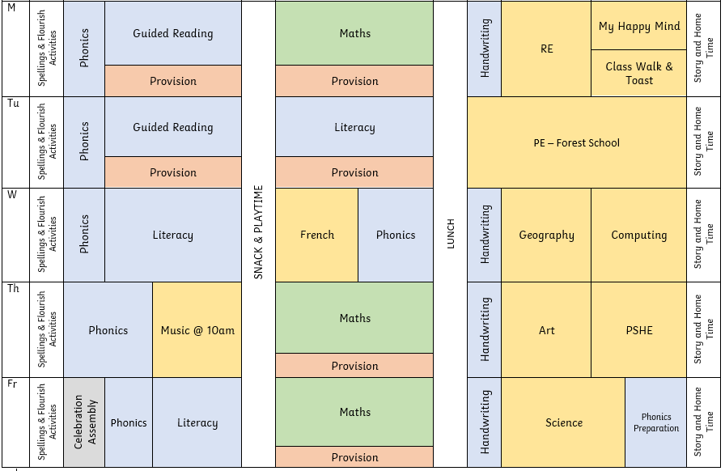

Things I need to remember…
- PE days – 1st and 2nd Tuesday (forest school) & 3rd, 4th and 5th Thursday (beach school)

If you have any questions or concerns, please don’t hesitate to message me on Class Dojo!

