Year 1 Newsletter
Summer Term 2
Welcome back I hope you had a great week off. I can’t believe we are in the last term of year one, how scary!
Our plans for this term…
This term we have got lots of exciting things ahead, we are going to be making healthy sandwiches for DT, exploring the monarchy and why we have castles for history, more about plants in science, why we should care for the world in RE, how to be a good friend in PSHE and athletics & football in PE!

Literacy
In Literacy we will be focusing on writing our own set of instructions on how to make a healthy sandwich with the inspiration from The Pet Potato – Mrs Beaney from Year 5 loves this book and highly recommend it!
For GPS we will be consolidating all previous knowledge and ensuring we can add the right punctuation to various sentences.

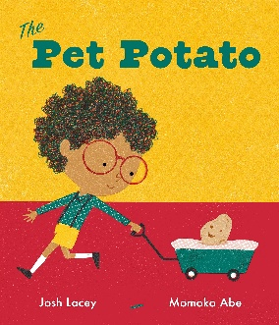

Phonics
We are spending the next couple of weeks revising all the sounds in preparation for the phonics screening check. All the information you need for this is either on ClassDojo or the class page on the school website.

Maths
In maths we will be focusing on finishing position and direction, then moving onto working with numbers up to 100 by counting in 10’s, partitions tens and ones and using number lines to 100. Then we will look at money, recognising the coins and notes. Finally, for our last topic in year 1 we will focus on time and being able to tell the time to the hour and half hour.

Reading
We will continue to complete reading checks on Monday and give out new Monster Phonics books. We are asking for book folders to be in school every day. As a school we ask that reading at home is done at least 3 times a week and a family member signs their reading record book.

Continuous Provision & Rainbow Challenges
In year 1, we will continue to offer a rich and engaging continuous provision. A highlight of our week is the Rainbow Challenge - children are encouraged to complete five activities throughout the week. Once they've collected all five, they receive a prize to celebrate their effort and resilience.

Timetable
Below I have attached a rough outline of what we will be doing each day – this can of course change depending on events we have in school.

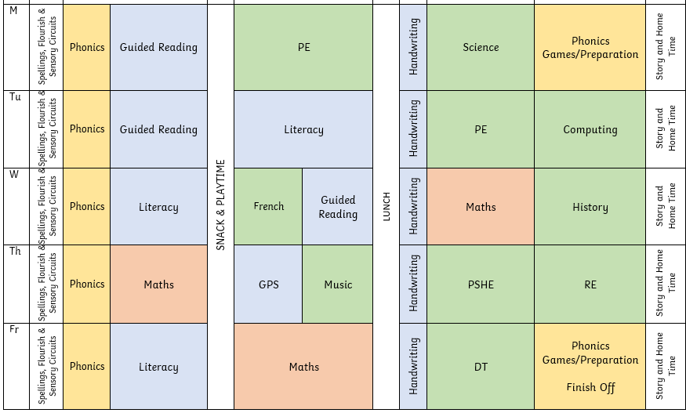

Things I need to remember…
- PE days – Monday and Tuesday

Future dates…
- Wednesday 3rd June - Term 6 begins
- Friday 5th June - Non-uniform day
- Monday 8th June - Year 1 phonics screening check (one week)
- Wednesday 10th June - Pickle ball event
- Thursday 11th June - Class Photos
- Wednesday 17th June - Sports day
- Wednesday 24th June - Parents Evening
- Friday 17th July - Final day of the year!

